**Investment options for NRIs in India**

**Types of NRI Bank Accounts**

* Non resident Indians are not allowed to operate a savings bank account in India.
* Therefore, they have to open certain different types of accounts in India for various purposes, including investments.

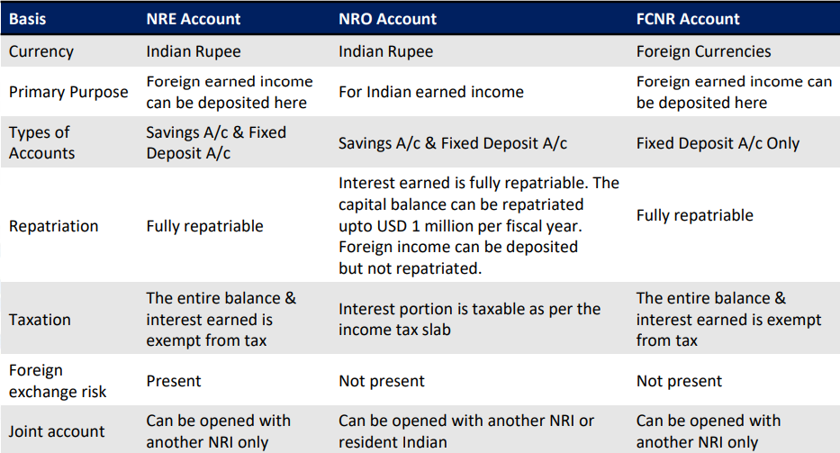

**Investment options & NRI**

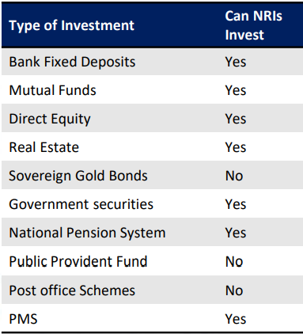

**NRI Taxation in Mutual Funds**

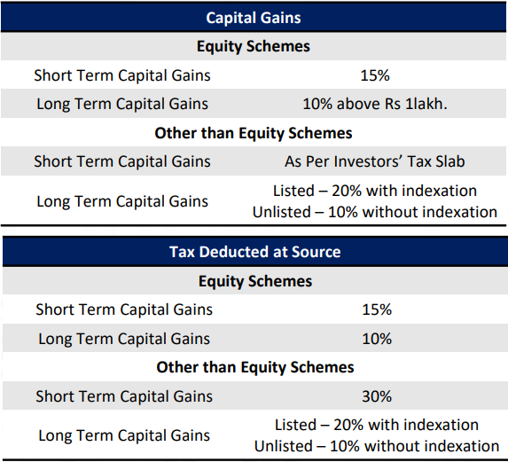

**NRI Taxation in Mutual Funds**

